**Questions on Location Management**

1. Explain the two processes in location management.
   * + 1. Location Tracking and Updating (Registration): A process in which an endpoint initiates a change in the Location Database according to its new location.
          1. This procedure allows the main system to keep track of a user's location so that for example an incoming call could be forwarded to the intended mobile user when a call exists or maybe bring a user's profile near to its current location so that it could provide a user with his/her subscribed services.
2. Location Finding (Paging): The process of which the network initiates a query for an end-point's location.
   1. This process is implemented by the system sending beacons to all cells so that one of the cells could locate the user. This might also result in an update to the location register

2. Relate the concept of La and PA.

For LM purposes, a wireless network usually consists of Location Areas (LAs) and Paging Areas (PAs). While LAs are a set of areas over which location updates take place, PAs are a set of areas over which paging updates take place. Usually, LAs and PAs are contiguous, but that's not the case always. In addition, a LA usually contains several PAs.

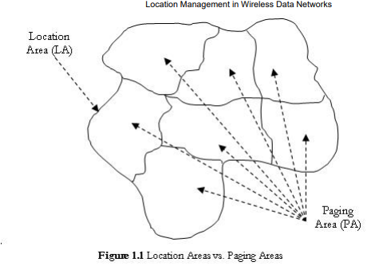

1. Explain the static LU schemes with limitations.

Three simple static Location Update schemes

* 1. being always-update : involves the user updating its location upon every inter-cell movement

Limitations -

* incur significant energy and computational costs to both the network and the user,
* may be particularly wasteful, as if a user makes frequent, quick movements within an LA,
* beginning and ending at the same location, many LUs will occur that might be unnecessary, especially if few or no calls are incoming.
  1. never-update : never require the user to inform the network of intercell movements, only updating on LA changes, and is named never-update

Limitations

* resources are saved as constant updates are not required, but paging costs rise substantially
* every cell within the user’s LA may need to be checked during paging due to the lack of information, which causes excessive overhead for users with a high incoming call frequency.
  1. static interval-based - each user within the network to update at static, uniform intervals. Balance between the extremes of the previous schemes, as the network will neither be overwhelmed with LUs nor wholly unaware of users’ locations.

Limitation-

* users with rapid rates of movement may move into new LAs between updates, which causes locating that user to be very difficult.
* an inactive user will not move at all, but will still regularly be sending unneeded LUs.

1. What are the issues in LM.

Current issues for LM involve

1. database architecture design,
2. transmission of signaling between various components of a signaling network,
3. security,
4. dynamic database updates,
5. querying delays,
6. terminal paging methods
7. paging delays.
8. What are LM schemes

Without Location Management

* + - * Is referred to as the Level 0 method.
      * The system doesn't track any mobile devices.
      * Searching for a user is done over the complete radio coverage area and within a specific time limit.
      * Is also referred to as the Flooding Algorithm.
      * It is used in paging
      * advantage-it is simple to implement because of the absence of a special database.
      * disadvantage- is that it doesn't fit into large networks dealing with high number of users and high incoming data exchange rates.

Manual Registration in Location Management

* + - * Is referred to as the Level 1 method.
      * The system is simple to manage because it only requires the management of an indicator which stores the current location of the user.
      * The mobile is relatively simple since its task is limited to scanning the channels to detect paging messages. An example of such a system is telepoint cordless systems.
      * The main disadvantage of this method is that users have to re-register each time they move.

Automatic Location Management using LAs

* Is referred to as the Level 2 method.
* Widely used and deployed in 1G and 2G cellular systems.
* Since this method is a LA based method, a home database and several visitor databases are included in the network architecture.

Memoryless-Based Location Management Methods

* These methods depend mainly on the processing capabilities of the system. They are based on algorithms and the network architecture.

Memory-Based Location Management Methods

* The design of memory-based location management methods has been motivated by the fact that systems perform many repetitive actions which can be avoided
* if predicted.

Location Management in Next Generation Systems

* The next generation in mobility management will enable different mobile networks to interoperate with each other to ensure terminal and personal mobility and
* global portability of network services. However, in order to ensure global mobility, the deployment and integration of both wired and wireless components is necessary.
* These future systems will all depend on the usages of Mobile IP. For example, the aim of 4G cellular networks is to deploy Mobile IP in its infrastructure so that users can switch between different access technologies.

1. Explain the call process in two level hierarchical database system in cellular communication.

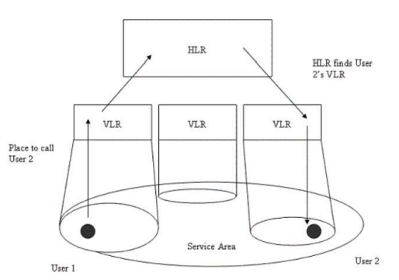

* The Home Location Register (HLR) contains the records of all users’ services, in addition to location information for an entire network.
* Visitor Location Registers (VLRs) download data from the HLR concerning current users within the VLR’s specific service areas.
* Each LA has one VLR servicing it, and each VLR is designed to only monitor one LA.
* Each VLR is connected to multiple Mobile Switching Centers (MSCs), which operate in the transport network in order to aid in handoffs and to locate users.

1. What are LM parameters explain.

* Paging
  1. Simultaneous Paging-
     1. every cell in the user’s LA is paged at the same time in order to find the user
     2. Quicker
     3. Cost wise inefficient
  2. Sequential Paging-each cell within an LA is paged in succession
     1. poll the cells nearest to the cell of the most recent LU, and then continue outward if the user is not immediately found.
  3. Intelligent Paging
     1. calculates specific paging areas to sequentially poll based upon a probability matrix.
     2. optimized version of Sequential Paging
* Mobility Models
  1. Mobility Model is **a model that describe the movement of mobile users and how their location, velocity and acceleration change over time**.

1. Explain indoor mobility models for individual node movement.

Indoor Mobility model, there are 3 parts- Random Walk, Random Way-Point, Random Direction.

1. What are the advantages of group based mobility models.

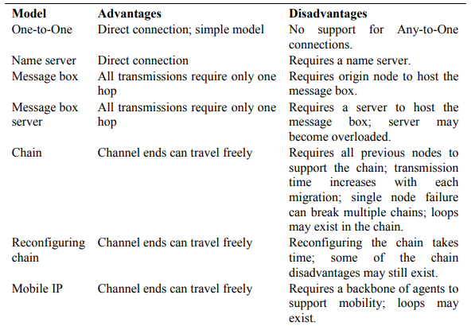

1. Explain dynamic LU schemes.

* Dynamic location update schemes allow per-user parameterisation of the location update frequency.
* account for the dynamic behaviour of users and may result in lower location management costs than static schemes.
* Unlike static location management strategies, a location update may be performed from any cell in the network, taking into consideration the call arrival and mobility patterns of the user.

1. Explain different paging techniques.

# Simultaneous Paging

The simultaneous paging scheme, also known as blanket paging, is the mechanism used in current GSM network implementations. Here all cells in the users location area are paged simultaneously, to determine the location of the mobile device. This requires no additional knowledge of user location but may generate excessive amounts of paging traffic.

# Sequential Paging

Sequential paging avoids paging every cell within a location area by segmenting it into a number of paging areas, to be polled one-by-one.

# Intelligent Paging

The intelligent paging scheme is a variation of sequential paging, where the paging order is calculated probabilistically based on pre-established probability metrics.

1. What is handoff and illustrate the scenarios of handoff.

The process of transferring an in-progress call from one cell or base station to a neighbouring cell without interruption.

Handoff Scenarios

* If a subscriber who is in a call or a data session moves out of coverage of one cell and enters coverage area of another cell, a handoff is triggered for a continuum of service. The tasks that were being performed by the first cell are delineating to the latter cell.
* Each cell has a pre-defined capacity, i.e. it can handle only a specific number of subscribers. If the number of users using a particular cell reaches its maximum capacity, then a handoff occurs. Some of the calls are transferred to adjoining cells, provided that the subscriber is in the overlapping coverage area of both the cells.
* Cells are often sub-divided into microcells. A handoff may occur when there is a transfer of duties from the large cell to the smaller cell and vice versa. For example, there is a traveling user moving within the jurisdiction of a large cell. If the traveler stops, then the jurisdiction is transferred to a microcell to relieve the load on the large cell.
* Handoffs may also occur when there is an interference of calls using the same frequency for communication.

1. Explain different types of handoff?

* Depending on the movement of the mobile device, it may undergo various types of handoff. In a broad sense, handoffs may be of two types: (i) **intra-system handoff (horizontal handoff) and (ii) inter-system handoff (vertical handoff)**.
* Handover within same access networks (e.g., WLAN-to-WLAN) is referred to as horizontal handover or intra-domain handover,
* Handover across heterogeneous access networks (e.g., GSM-to- WiMAX) is referred to as the vertical or Inter-domain handover.

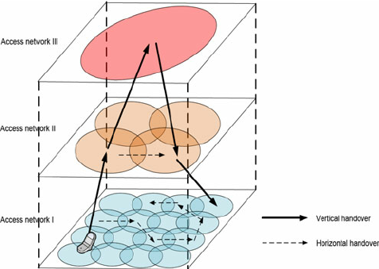

1. Explain group based mobility models.

* Reference point based group mobility model

* Community based group mobility model

1. How is movement-based LU different from distance-based LU.

The movement-based update scheme requires mobile devices to update their location after a given number of boundary-crossings to other cells in the network. This boundary-crossing threshold may be assigned per-user, optimised for individual movement and call arrival rates

In a distance-based scheme the mobile device performs a location update when it has moved a certain distance from the cell where it last updated its location. Again, this distance threshold may be optimised per-user according to movement and call arrival rates.

